N-gonal Cupola

Definition
# Source: AI Source: Provided by: [Data Path: Persons Table -> ID Column: 1, Name_En Column: Motasem Essam] -> From: [ChatGPT] on [7/25/2026]
An N-gonal Cupola is a convex polyhedron consisting of two parallel polygonal bases: a regular $n$-sided upper base and a regular $2n$-sided lower base.
The two bases are connected by an alternating arrangement of $n$ triangular faces and $n$ square or rectangular faces.
It belongs to the family of cupolas, where $n$ represents the number of sides of the upper polygon.
The N-gonal Cupola is also a type of prismatoid, because its two polygonal bases lie in parallel planes.
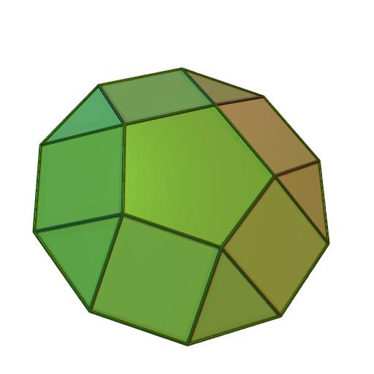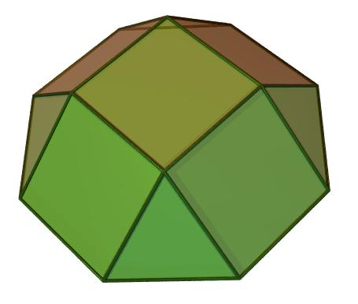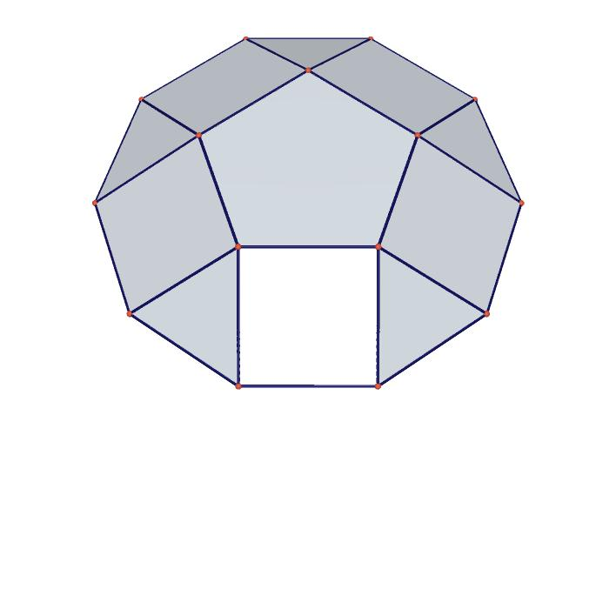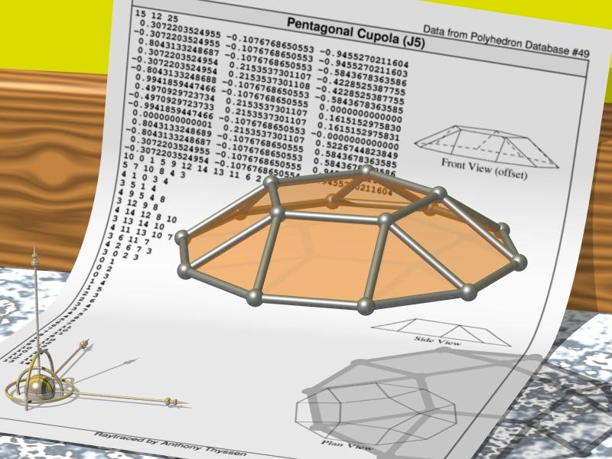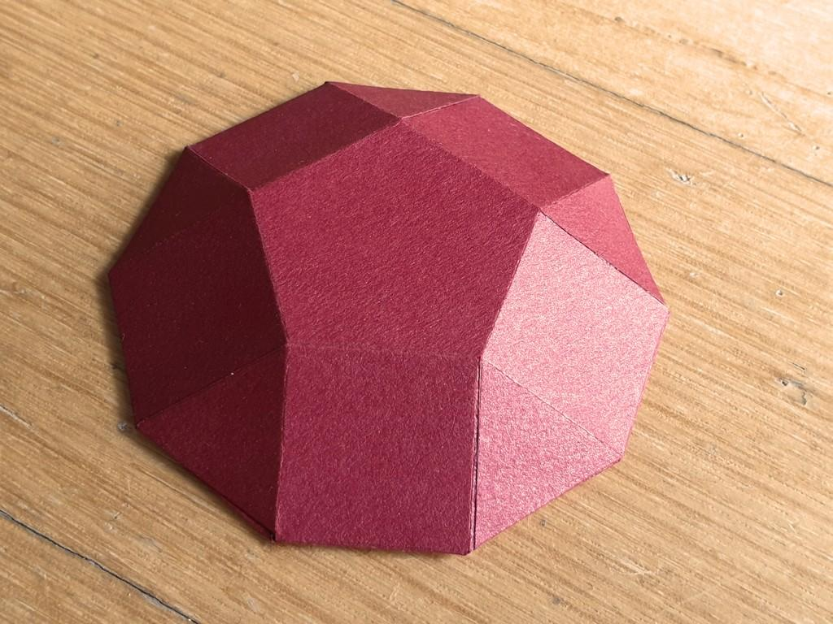

Simple Definition
# Source: AI Source: Provided by: [Data Path: Persons Table -> ID Column: 1, Name_En Column: Motasem Essam] -> From: [ChatGPT] on [7/25/2026]
An N-gonal Cupola is a solid with:
- One regular $n$-sided upper base.
- One regular $2n$-sided lower base.
- $n$ triangular lateral faces.
- $n$ square or rectangular lateral faces.
- $2n+2$ faces in total.
- $5n$ edges.
- $3n$ vertices.

Geometric Structure
# Source: AI Source: Provided by: [Data Path: Persons Table -> ID Column: 1, Name_En Column: Motasem Essam] -> From: [ChatGPT] on [7/25/2026]
The N-gonal Cupola consists of four main structural elements:
- Upper Base: A regular polygon with $n$ sides.
- Lower Base: A regular polygon with $2n$ sides.
- Central Axis: Passes through the centers of both bases and is perpendicular to their planes in the standard right cupola.
- Lateral Surface: Connects the two bases through alternating triangular and square or rectangular faces.
The $n$ upper vertices correspond to alternating vertices of the lower $2n$-sided polygon.
This arrangement produces the characteristic cupola structure.

Face Structure
# Source: AI Source: Provided by: [Data Path: Persons Table -> ID Column: 1, Name_En Column: Motasem Essam] -> From: [ChatGPT] on [7/25/2026]
An N-gonal Cupola has:
$$\boxed{F=2n+2}$$
faces in total.
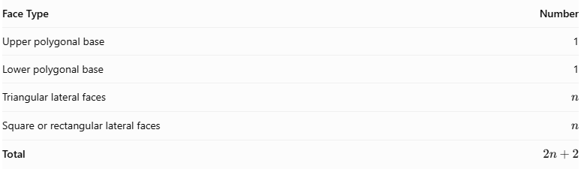
Face Type | Number
Upper polygonal base | 1
Lower polygonal base | 1
Triangular lateral faces | $$n$$
Square or rectangular lateral faces | $$n$$
Total | $$2n+2$$
The lateral faces alternate around the solid:
- $n$ triangular faces.
- $n$ square or rectangular faces.
Important: In a general N-gonal Cupola, the quadrilateral lateral faces are not necessarily squares. In the regular Johnson-solid cupolas, the triangular, square, and pentagonal cupolas have equilateral triangles and square lateral faces. For larger $n$, the regular-faced arrangement is not possible with all lateral triangles equilateral and all quadrilaterals square.

Edge Structure
# Source: AI Source: Provided by: [Data Path: Persons Table -> ID Column: 1, Name_En Column: Motasem Essam] -> From: [ChatGPT] on [7/25/2026]
An N-gonal Cupola has:
$$\boxed{E=5n}$$
edges.
The edges are divided into three groups:
- $n$ edges around the upper polygonal base.
- $2n$ edges around the lower polygonal base.
- $2n$ connecting edges between the two bases.
Therefore:
$$E=n+2n+2n$$
$$\boxed{E=5n}$$
Each edge is shared by exactly two faces.

Vertex Structure
# Source: AI Source: Provided by: [Data Path: Persons Table -> ID Column: 1, Name_En Column: Motasem Essam] -> From: [ChatGPT] on [7/25/2026]
An N-gonal Cupola has:
$$\boxed{V=3n}$$
vertices.
The vertices are divided into two groups:
- $n$ vertices on the upper polygonal base.
- $2n$ vertices on the lower polygonal base.
Therefore:
$$V=n+2n$$
$$\boxed{V=3n}$$
In the standard cupola arrangement:
- Each upper vertex is shared by 4 faces.
- Each lower vertex is shared by 3 faces.

Mathematical Properties
# Source: AI Source: Provided by: [Data Path: Persons Table -> ID Column: 1, Name_En Column: Motasem Essam] -> From: [ChatGPT] on [7/25/2026]
The mathematical properties of an N-gonal Cupola can be expressed using the variable $n$.
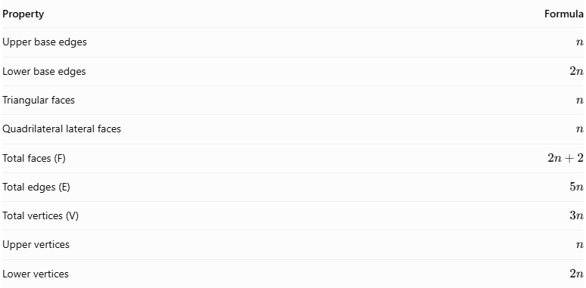
Property | Formula
Upper base edges | $$n$$
Lower base edges | $$2n$$
Triangular faces | $$n$$
Quadrilateral lateral faces | $$n$$
Total faces (F) | $$2n+2$$
Total edges (E) | $$5n$$
Total vertices (V) | $$3n$$
Upper vertices | $$n$$
Lower vertices | $$2n$$
Euler's Formula
Every convex polyhedron satisfies:
$$V-E+F=2$$
Substituting the N-gonal Cupola formulas:
$$3n-5n+(2n+2)=2$$
$$\boxed{2=2}$$
Therefore, the N-gonal Cupola satisfies Euler's formula.

Face Incidence
# Source: AI Source: Provided by: [Data Path: Persons Table -> ID Column: 1, Name_En Column: Motasem Essam] -> From: [ChatGPT] on [7/25/2026]
Face incidence describes how faces meet at the vertices.
An N-gonal Cupola has two different vertex arrangements:
At Each Upper Vertex:
- One upper polygonal face.
- Two triangular lateral faces.
- One quadrilateral lateral face.
Therefore, 4 faces meet at each upper vertex.
At Each Lower Vertex:
- One lower polygonal face.
- One triangular lateral face.
- One quadrilateral lateral face.
Therefore, 3 faces meet at each lower vertex.
The general vertex configurations are:
- Upper vertices: $3.4.n.4$
- Lower vertices: $3.4.2n$
These configurations describe the standard alternating arrangement of triangular and quadrilateral faces.

Surface Area and Volume

Surface Area
# Source: AI Source: Provided by: [Data Path: Persons Table -> ID Column: 1, Name_En Column: Motasem Essam] -> From: [ChatGPT] on [7/25/2026]
The total surface area is the sum of the areas of both polygonal bases and all lateral faces.
$$\boxed{S=A_{n}+A_{2n}+{nA}_{t}+{nA}_{q}}$$
Where:
- $A_{n}$ = Area of the upper regular $n$-sided polygon.
- $A_{2n}$ = Area of the lower regular $2n$-sided polygon.
- $A_{t}$ = Area of one triangular lateral face.
- $A_{q}$ = Area of one quadrilateral lateral face.
For a regular polygon with $m$ sides of length $a$:
$$A=\frac{{ma}^{2}}{4tan(π/m)}$$
The total surface area depends on the actual dimensions of the cupola.

Volume
# Source: AI Source: Provided by: [Data Path: Persons Table -> ID Column: 1, Name_En Column: Motasem Essam] -> From: [ChatGPT] on [7/25/2026]
An N-gonal Cupola is a prismatoid. Its volume can be calculated using the prismatoid formula:
$$\boxed{V=\frac{h}{6}(A_{1}+4A_{m}+A_{2})}$$
Where:
- $h$ = Perpendicular distance between the base planes.
- $A_{1}$ = Area of the upper polygonal base.
- $A_{2}$ = Area of the lower polygonal base.
- $A_{m}$ = Area of the cross-section halfway between the bases.
A numerical volume requires the dimensions and relative positioning of the bases.

Symmetry
# Source: AI Source: Provided by: [Data Path: Persons Table -> ID Column: 1, Name_En Column: Motasem Essam] -> From: [ChatGPT] on [7/25/2026]
A standard symmetric N-gonal Cupola has the following symmetry properties:
- Rotational Symmetry: $n$-fold rotational symmetry around its central axis.
- Vertical Reflection Symmetry: $n$ vertical reflection planes passing through the central axis.
- Horizontal Reflection Symmetry: Not generally present because the upper and lower bases have different numbers of sides.
- Central Symmetry: Not generally present.
Its symmetry group is:
$$\boxed{C_{nv}}$$
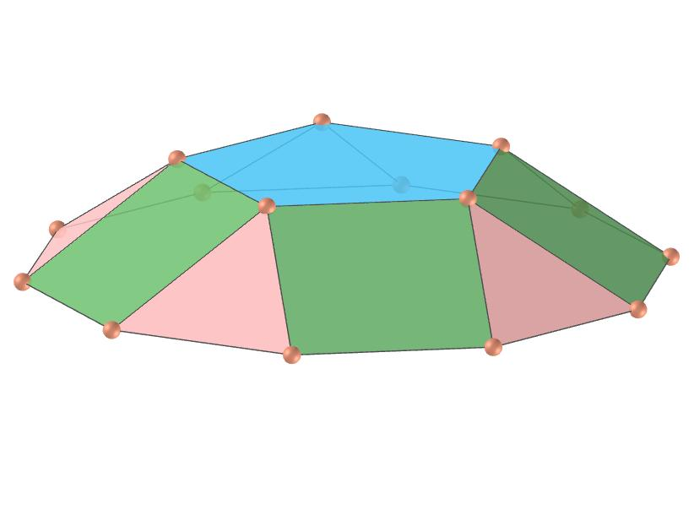

Relationship to Other Solids
# Source: AI Source: Provided by: [Data Path: Persons Table -> ID Column: 1, Name_En Column: Motasem Essam] -> From: [ChatGPT] on [7/25/2026]
The N-gonal Cupola is the general form of the cupola family.
Examples include:
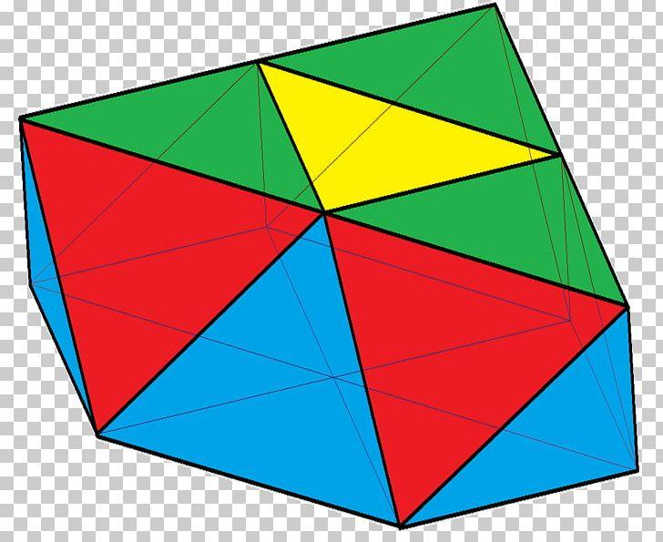
Triangular Cupola
3-sided upper base and 6-sided lower base.
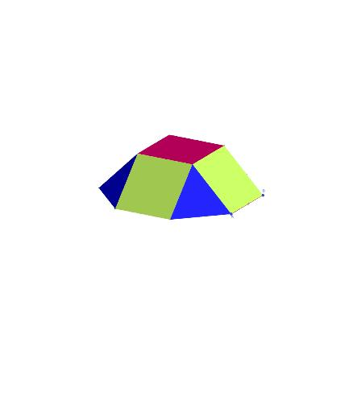
Square Cupola
4-sided upper base and 8-sided lower base.
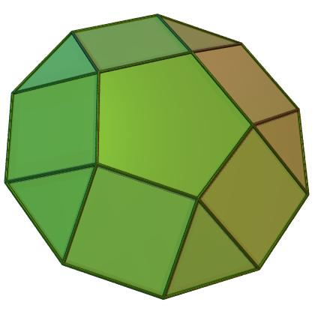
Pentagonal Cupola
5-sided upper base and 10-sided lower base.
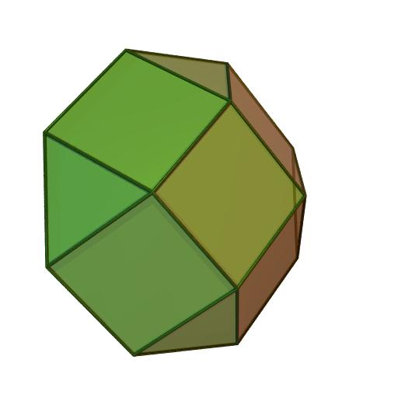
Decagonal Cupola
10-sided upper base and 20-sided lower base.
The family also includes:
- Hexagonal Cupola.
- Heptagonal Cupola.
- Octagonal Cupola.
- Nonagonal Cupola.
- Other N-gonal Cupolas.
All follow the same general face, edge, and vertex formulas.

Worked Example
# Source: AI Source: Provided by: [Data Path: Persons Table -> ID Column: 1, Name_En Column: Motasem Essam] -> From: [ChatGPT] on [7/25/2026]
Problem: Find the number of faces, edges, and vertices of a 12-gonal Cupola.
Solution:
Given:
$$n=12$$
Step 1: Calculate the number of faces.
$$F=2n+2$$
$$F=2(12)+2$$
$$\boxed{F=26}$$
Step 2: Calculate the number of edges.
$$E=5n$$
$$E=5(12)$$
$$\boxed{E=60}$$
Step 3: Calculate the number of vertices.
$$V=3n$$
$$V=3(12)$$
$$\boxed{V=36}$$
Final Answer:
- Faces = 26.
- Edges = 60.
- Vertices = 36.

Constructing N-gonal Cupola in Solid Geometry

Geometric Instruments Used
# Source: AI Source: Provided by: [Data Path: Persons Table -> ID Column: 1, Name_En Column: Motasem Essam] -> From: [ChatGPT] on [7/25/2026]
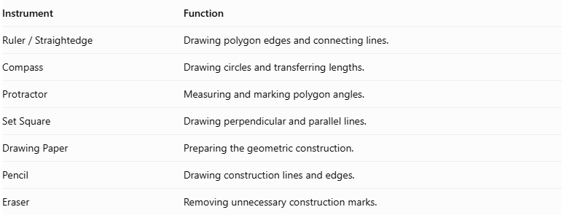
Instrument | Function
$$Ruler/Straightedge$$ | Drawing polygon edges and connecting lines.
Compass | Drawing circles and transferring lengths.
Protractor | Measuring and marking polygon angles.
Set Square | Drawing perpendicular and parallel lines.
Drawing Paper | Preparing the geometric construction.
Pencil | Drawing construction lines and edges.
Eraser | Removing unnecessary construction marks.

Instrument-Based Construction Procedures

Determining the Polygon Dimensions
# Source: AI Source: Provided by: [Data Path: Persons Table -> ID Column: 1, Name_En Column: Motasem Essam] -> From: [ChatGPT] on [7/25/2026]
For an N-gonal cupola:
- Upper base: $n$ sides.
- Lower base: $2n$ sides.
- Triangular lateral faces: $n$.
- Quadrilateral lateral faces: $n$.
The central angles are:
Upper Base:
$$θ_{u}=\frac{{360}^{°}}{n}$$
Lower Base:
$$θ_{l}=\frac{{360}^{°}}{2n}=\frac{{180}^{°}}{n}$$

Constructing the Lower $2n$-gonal Base
# Source: AI Source: Provided by: [Data Path: Persons Table -> ID Column: 1, Name_En Column: Motasem Essam] -> From: [ChatGPT] on [7/25/2026]
- Draw a circle using a compass.
- Mark its center.
- Divide the circle into $2n$ equal angular sections.
- Each central angle measures:
$$θ_{l}=\frac{{180}^{°}}{n}$$
- Mark the $2n$ points around the circumference.
- Connect consecutive points using a ruler.
- Complete the regular lower polygon.
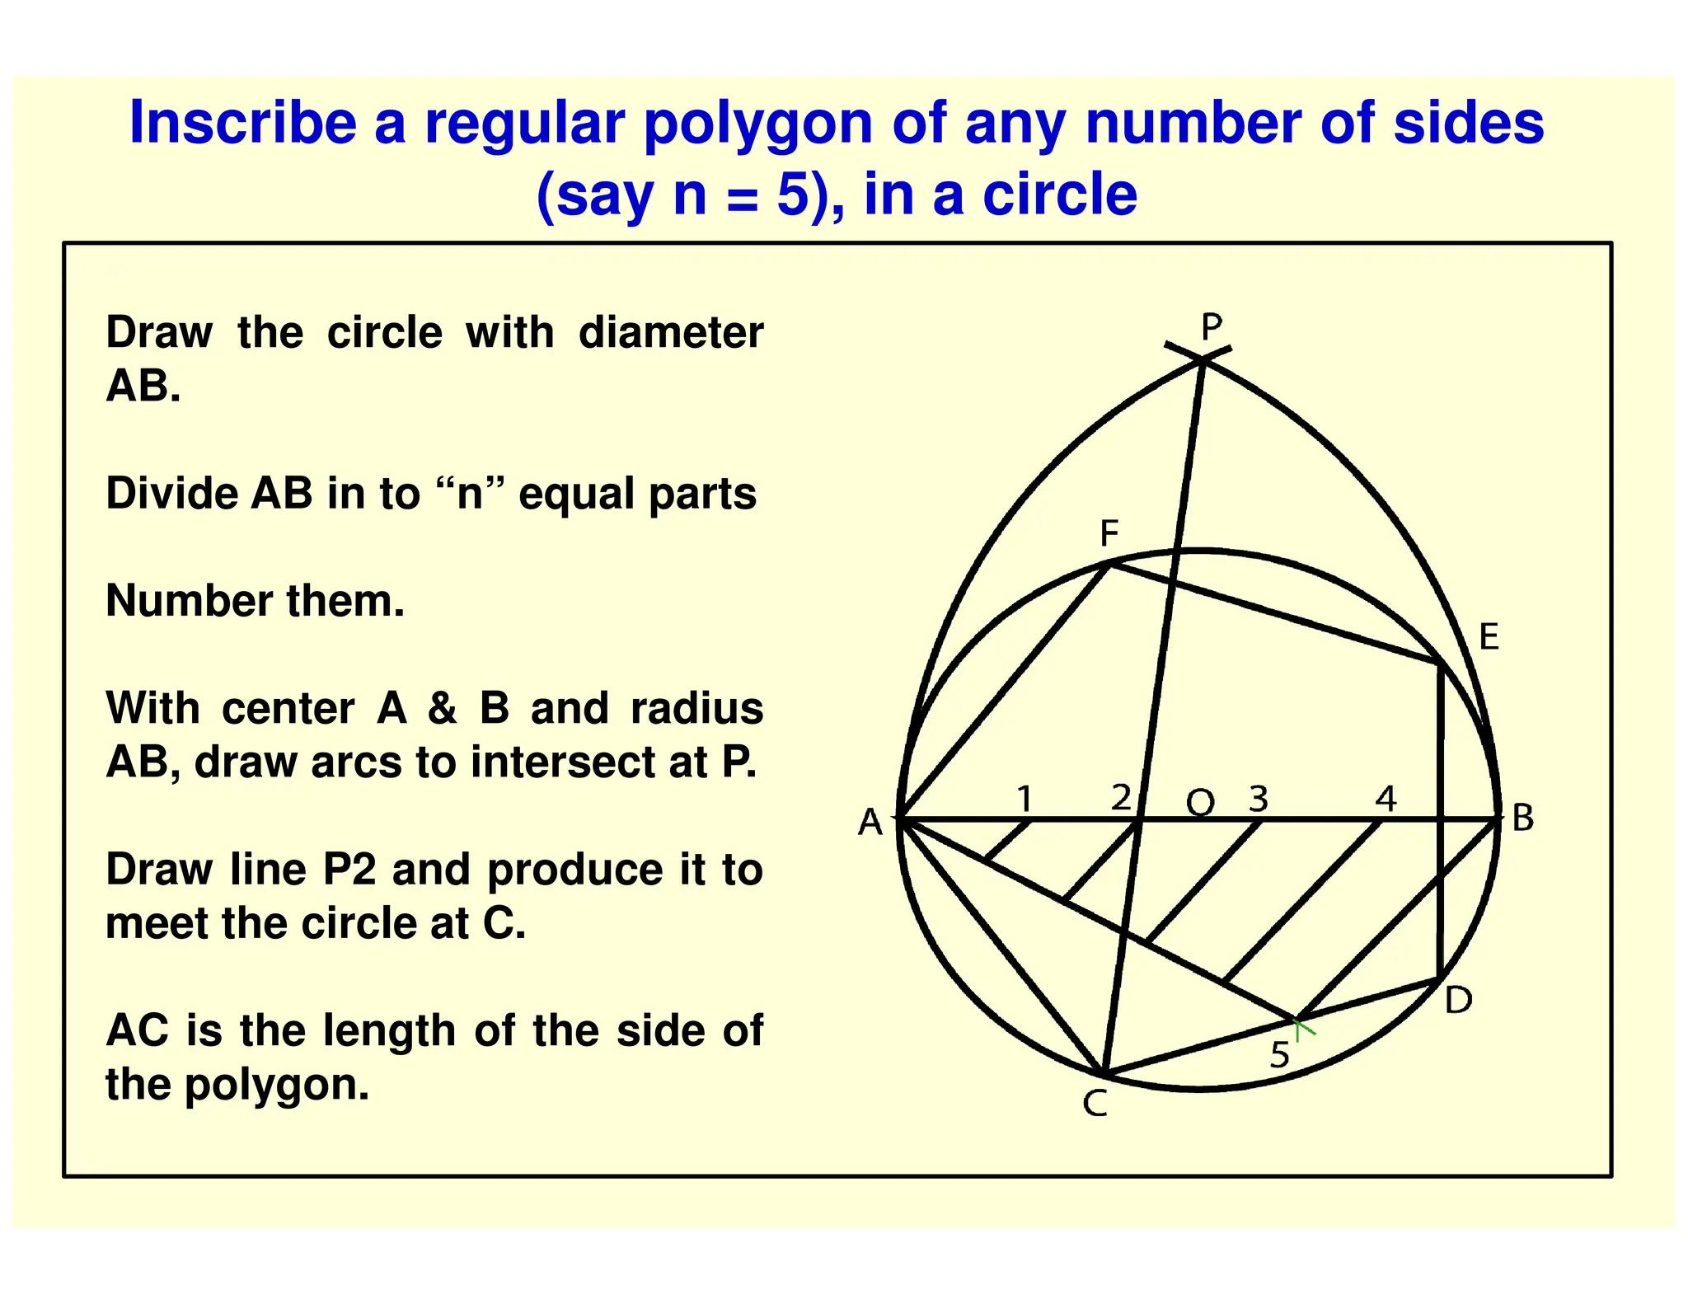

Constructing the Upper N-gonal Base
# Source: AI Source: Provided by: [Data Path: Persons Table -> ID Column: 1, Name_En Column: Motasem Essam] -> From: [ChatGPT] on [7/25/2026]
- Draw a second circle using a compass.
- Mark its center.
- Divide the circle into $n$ equal angular sections.
- Each central angle measures:
$$θ_{u}=\frac{{360}^{°}}{n}$$
- Mark the $n$ points around the circumference.
- Connect consecutive points using a ruler.
- Complete the regular upper polygon.
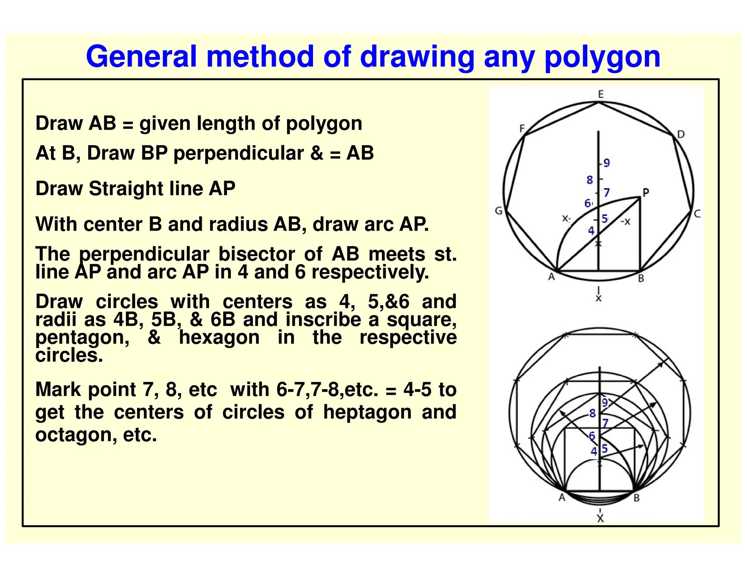

Positioning the Two Bases
# Source: AI Source: Provided by: [Data Path: Persons Table -> ID Column: 1, Name_En Column: Motasem Essam] -> From: [ChatGPT] on [7/25/2026]
- Draw the lower $2n$-gonal base.
- Draw the upper $n$-gonal base above the lower base.
- Keep both polygonal bases parallel.
- Position the upper polygon so its vertices and the lower polygon's edges follow the intended alternating cupola arrangement.
- Maintain the intended rotational symmetry around the central axis.
- Ensure that the selected dimensions and vertical separation produce a geometrically consistent solid.

Constructing the Triangular Faces
# Source: AI Source: Provided by: [Data Path: Persons Table -> ID Column: 1, Name_En Column: Motasem Essam] -> From: [ChatGPT] on [7/25/2026]
- Identify the $n$ triangular face positions.
- Connect the appropriate vertices of the upper and lower bases.
- Draw the edges that form the triangular lateral faces.
- Check that each triangle shares its edges with the correct neighboring faces.

Constructing the Quadrilateral Faces
# Source: AI Source: Provided by: [Data Path: Persons Table -> ID Column: 1, Name_En Column: Motasem Essam] -> From: [ChatGPT] on [7/25/2026]
- Identify the $n$ positions between the triangular faces.
- Connect the remaining corresponding vertices and base-edge endpoints.
- Form the quadrilateral lateral faces.
- Verify that each quadrilateral joins the appropriate neighboring triangles and base edges.

Completing the Three-Dimensional Representation
# Source: AI Source: Provided by: [Data Path: Persons Table -> ID Column: 1, Name_En Column: Motasem Essam] -> From: [ChatGPT] on [7/25/2026]
- Review all lateral connections.
- Check that all faces form one closed polyhedral surface.
- Distinguish visible edges from hidden edges.
- Erase unnecessary construction lines.
- Add shading to distinguish the triangular and quadrilateral faces.
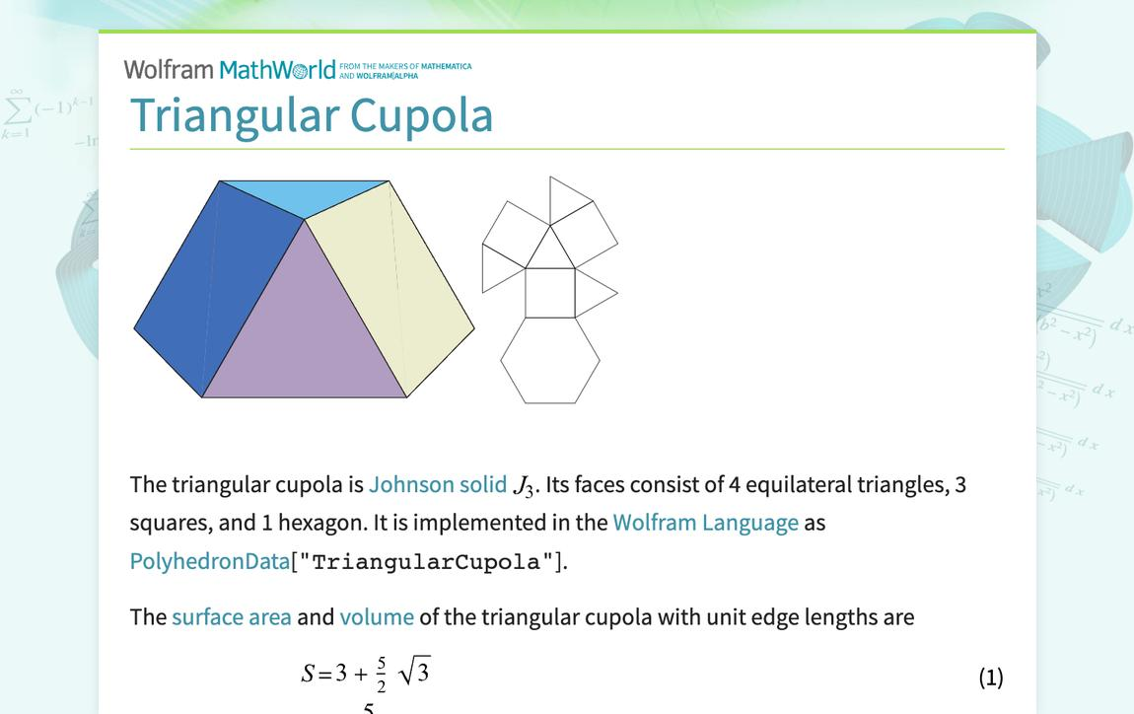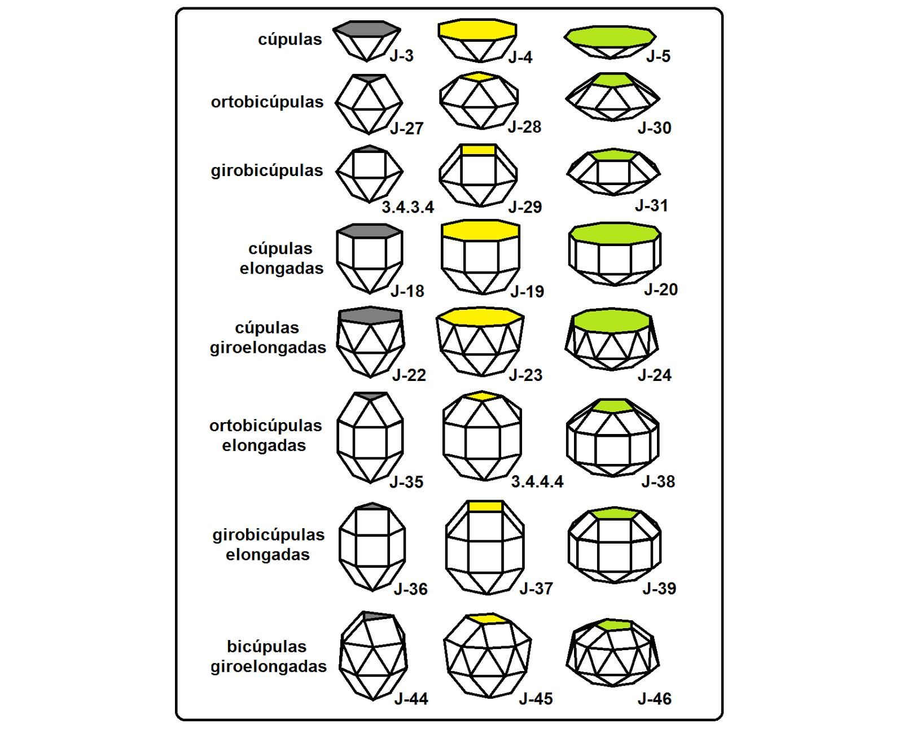

Key Points
# Source: AI Source: Provided by: [Data Path: Persons Table -> ID Column: 1, Name_En Column: Motasem Essam] -> From: [ChatGPT] on [7/25/2026]
- An N-gonal Cupola has an $n$-sided upper base.
- Its lower base has $2n$ sides.
- It has $n$ triangular lateral faces.
- It has $n$ quadrilateral lateral faces.
- It has $2n+2$ faces in total.
- It has $5n$ edges.
- It has $3n$ vertices.
- Each upper vertex is shared by 4 faces.
- Each lower vertex is shared by 3 faces.
- It has $n$-fold rotational symmetry.
- It is a prismatoid.
- It is the general form of the Cupola family.

Conclusion
# Source: AI Source: Provided by: [Data Path: Persons Table -> ID Column: 1, Name_En Column: Motasem Essam] -> From: [ChatGPT] on [7/25/2026]
The N-gonal Cupola is a convex polyhedron characterized by two parallel polygonal bases, an $n$-sided upper base, a $2n$-sided lower base, and an alternating arrangement of triangular and quadrilateral lateral faces.
Its mathematical structure follows general formulas for faces, edges, and vertices, making it an important family in the study of solid geometry and polyhedral structures.

